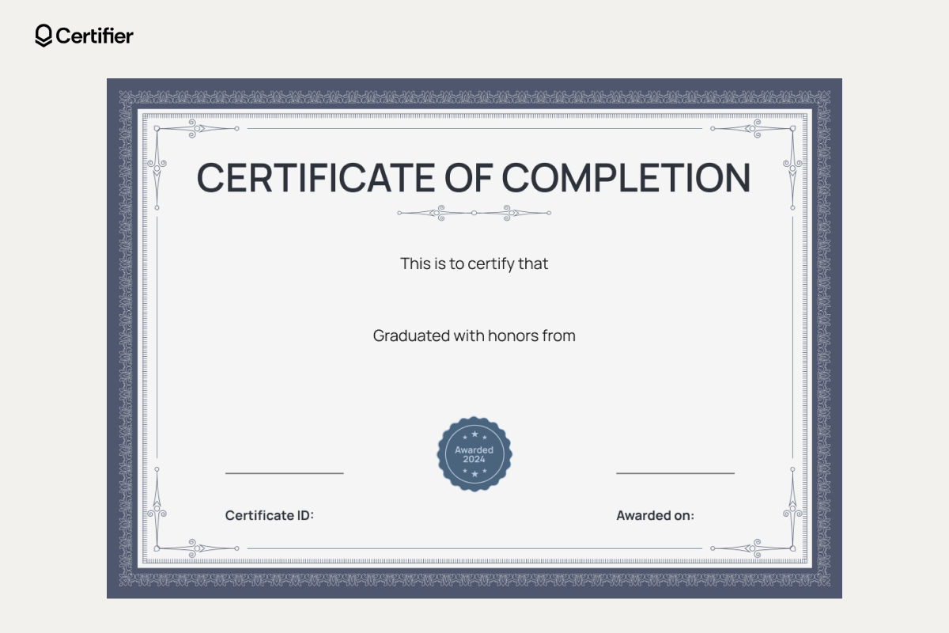
2026-09-04 00:00:00
23CSE004
Mechanical
Arjun Verma

